Date: Nov 29, 2018
Site ID: DHDHN25 Site Name: Eastern Plaza IBS
To,
Authority

Subject: Seeking permission to Site Survey, Material Receive & Installation and PAT.

Dear Sir,

Greetings from ROBI !

With due respect & honor, we would like to request you to provide necessary permission to our assigned following personnel to access/enter to our BTS site for conducting infrastructure sharing survey / up gradation work as it may require at our site. The schedule has been given below for your kind perusal:

Schedule for Survey / up gradation work
Date | From : 29-Nov-2018 | To: 29-Nov-2018
Time | 09:00AM to 06:00PM (Each day)
Vendor Name | SARBS Communication Ltd.
Vendor Responsible | Feroz Ahmed-01844021504
Robi Responsible | Gias Kamal- +8801833181418

Therefore, we humbly request you to take the entire matter into your generous consideration and convey us your approval so that our assigned personnel can do the essentials from their end.

We would like to thank you for the cooperation that we received so far & look forward for the same in coming days.
Thanking you.

With Best Regards,

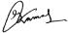

_________________
Gias Kamal
Implementation, ANR
Robi Axiata limited
Uday Tower, (17th Floor)
57&57A, Gulshan Avenue
Gulshan-1, Dhaka-1212.



Vendor/ Third Party/ Contactor People Details:
Sl | Name | Designation, Department & Company | Phone No | National ID NO. | Photo Snap
1 | Md. Zakaria Kisar | Site Engineer  SARBS | 01939653309 | 3730594078 | 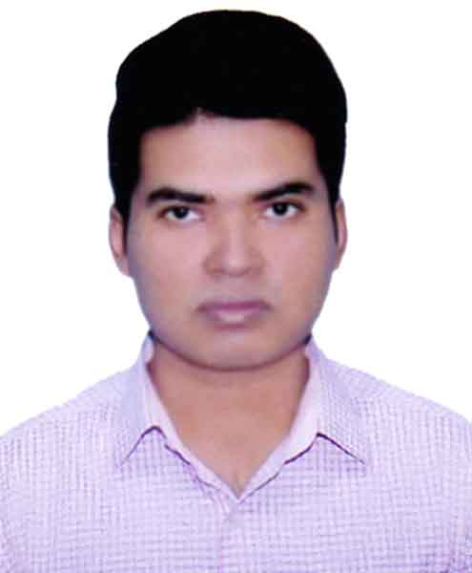
2 | Md. Earshad Ali | Team Leader  SARBS | 01731354313 | 19882690815015640 | 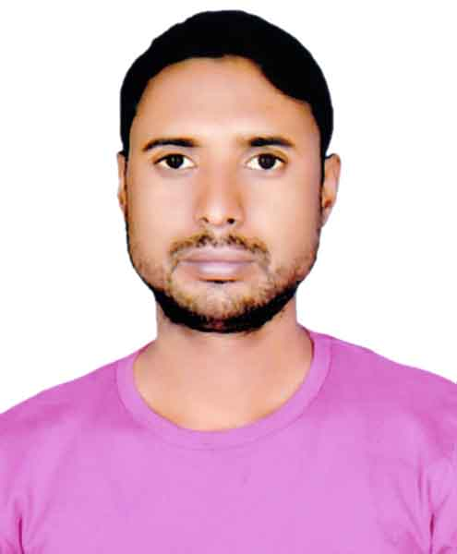
3 | Md. Shamim Hossain | Technician  SARBS | 01680029907 | 19882690821175777 | 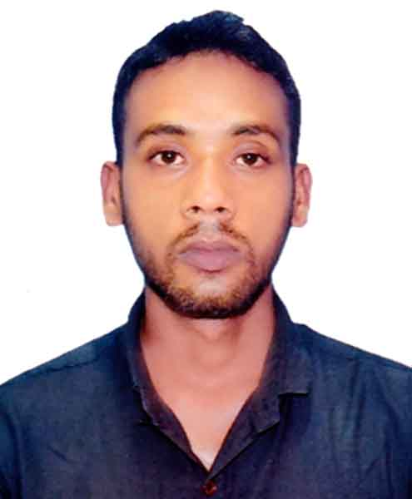
1 | Md. Sahariar Iqbal | Site Engineer  SARBS | 01738120586 | 19942716443000124 | 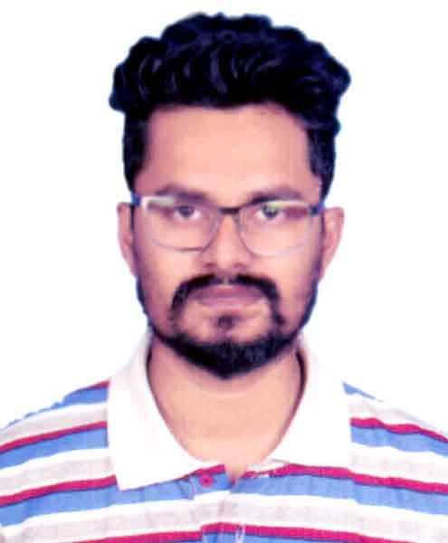
2 | Md. Mahabub Alom | Team Leader  SARBS | 01745062103 | 19914418063000212 | 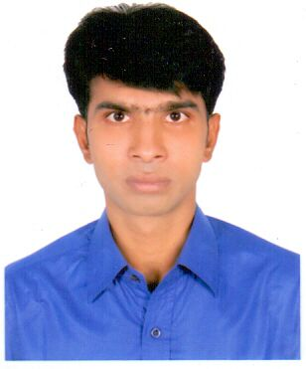
3 | Md. Nazrul islam | Technician  SARBS | 01680029907 | 19882690821175777 | 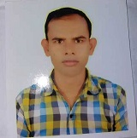

Schedule for Survey / up gradation work/ Dismantle
Date | From : 28-November-2018 | To: 28-December-2018
Time | 09:00AM to 06:00PM (each day)
Vendor Name | SARBS Communication Ltd.
Vendor Responsible | Feroz Ahmed-01844021504
Robi Responsible | Md. Saleh Forhad_Cell : 01833181137

Thanking you.

With Best Regards,

_________________
Gias Kamal
Implementation, ANR
Robi Axiata limited
Uday Tower, (17th Floor)
57&57A, Gulshan Avenue
Gulshan-1, Dhaka-1212.

